May 13, 2024

Engg1100 Purple Team

Faculty of EAIT

The University of Queensland

Dear Flood Safe Havens,

We submit a proof-of-concept prototype for a Station Keeping Flood Resistant Housing alongside documentation detailing the design and development. Decision making and team dynamics throughout the project have also been analysed. The design prototype has been reflected upon and scale-up potential has been considered to provide a detailed conclusion with recommendations for the future of the project.

Sincerely,

ENGG1100 Purple Team



ENGG1100 Final Report

Team Purple – (Andrew, Bryson, Calvin, Chris, Kyle, Vincent, Zavier)

Executive Summary

This engineering report aims to develop, design, and test a flood-resistant house for the client Flood Safe Havens. This engineering portfolio introduced the task and highlighted all constraints the project must adhere to from Flood Safe Havens. Specific engineering principles such as Archimedes' principle and Hooke's Law were used within the report to complete the solution effectively. Based on the client's criteria and constraints, a pair-wise comparison and decision-making matrix was used to determine the most effective solution. The decision-making matrix resulted in choosing a passive control and four mechanical winch system. The designed structure of the prototype aligned with all of the client's dimensional constraints, using high-density closed-cell EVA foam for the foundation and acrylic for the house structure. The constructed drive system satisfied all the client's criteria and constraints by using four mechanical winches to generate sufficient stability and station-keeping ability. The constructed passive control system effectively aligned with the client's criteria and constraints, by applying Hooke's Law to the spiral springs within the winches. The risk surrounding the project was subsequently reduced by using specific improvements to equipment and techniques. The initial testing of the prototype resulted in positive results. However, issues surrounding the centre of gravity and stability of the house were noted and subsequently improved for the final prototype which received a total performance score of 94%. Scale-up considerations were stressed by considering cost, manufacturing process, manufacturing problems, and substitutable materials. Aluminium foam is suggested as a substitute for EVA foam, and timber is suggested to substitute the acrylic house. The sustainable life cycle of the scaled-up project was documented to ensure the sustainability of the house. A final critical analysis by the team was completed regarding the effectiveness of the group in completing the task assigned by the client. The overall project concluded by restating the group's progress throughout the project and the solution's effectiveness.

Table of Contents

Table of Contents 4

List of Tables 5

List of Figures 5

Introduction 6

Scope 6

Technical Background 7

Decision Analysis 9

Detailed Design 12

Technical Specifications 12

Structure 13

Drive 14

Power and Control 15

Budget 16

Risk Analysis 17

Description of Prototype Operation 18

Scale-Up Considerations 20

Sustainability Assessment 21

Team Reflection 22

Conclusion and Recommendations 24

References 25

Appendices: 29

Appendix 1: Receipts for Materials 29

Appendix 2: Team Members’ Critical Analysis 32

List of Tables

Table 1: Pair-Wise Comparison 9

Table 2: Decision Making Matrix 10

Table 3: Sensitivity Analysis 11

Table 4: Budget record 16

Table 5: FMEA 17

Table 6: Life Cycle Assessment 21

List of Figures

Figure 1: Function Means Tree 9

Figure 2: System level prototype 12

Figure 3: 3D Model of Prototype with measurements 13

Figure 4: 3D printed mechanical winch 14

Figure 5: 3D Modelled Winch Body 14

Figure 6: 3D Modelled Eye Bolt 15

Figure 7: Spiral spring control system 15

Figure 8: Mechanical winch testing results 18

Figure 9: Discord Discussions... 19

Figure 10: Meeting Booking... 20

# Introduction

In modern society, the current state of urban housing and urban sprawl has inevitably left many communities largely affected by the destructive influence of natural disasters. The immediate effects of such natural disasters can lead to heavy economic downturn for heavily affected communities and can require a national or global aid effect for even one community to recover from natural disasters. Currently a large scale, global disaster which affects most communities around the world is the impact of flooding or flash flooding. When considering long periods of excessive flooding some impacted areas may never fully recover economically or geographically. The impact of floods, although not necessarily heavy in casualties, is certainly a manageable disaster which can be avoided with careful engineering, limiting flood damages. This report will outline the method by which a floating house can be constructed to withstand flood levels for the current day and accounting for the potential increase in flood heights in the future. This project aims to produce a workable prototype to solve the problem of practical housing and building for flood prone regions to limit the impact of flooding on these communities (Xian, 2024).

This engineering portfolio aims to develop, design and test a flood resistant house as part of the not-for-profit organization, Flood Safe Havens. Flood Safe Havens aims to provide community centres that are resistant to the extreme conditions caused by floods, for high-risk areas such as the Philippines where the local population can seek refuge during extreme weather events. In response to the flooding, the client has requested that the prototype solution should float and is able to return to its original position after the flood waters recede to their original levels. This report documents all design, developmental and testing stages of the prototype solution, including, all decision-making methods, a team reflection and an analysis of the design. Final conclusions and recommendations have been documented within the report.

# Scope

The brief (UQ, 2024) requires a proof-of-concept prototype for “Station Keeping Flood Resistant Housing” along with documentation of the development, design and scale up considerations. Important objectives according to the client include safety of the residents, cost effectiveness, environmental impact and social implications on the community. The client advises that the prototype should include three sub-systems, namely “structure”, “drive” and “power and control”.

The brief has given the following constraints for the prototype (refer to Learning Guide for a comprehensive description (UQ, 2024)):

1. Minimum floor area is 48000mm2.
2. Maximum dimensions are 300 x 300 x 230mm (length x width x height) where:
   1. Locater tag mounted on top must be within max height.
   2. Drive and structure sub-systems must be within dimensions before deployment.
   3. Cabling and remote-control components can be located outside of the design (excluding external tethering).
   4. Maximum underwater draft is 70mm.
3. Maximum of 12V and 2A power supply.
4. Control can be manual, semi-automatic or automatic.
5. Structure must include openable doors and windows measuring at least 50 x 30mm.
6. There must be an open area in the centre of the building measuring at least 155 x 155 x 150mm.
7. No rigid attachments (excluding cables) to baseplate taller than 80mm.

The brief (UQ, 2024) has also detailed that the test rig environment will be 826 x 583mm with a contact plate (baseplate) of 380 x 380mm and peak flood height of 150 to 200mm. The test rig will include a 2.2kg assessment box (placed inside the house) with a moving weight inside to test the stability of the floating house. Furthermore, there will be fans blowing at a max of 2m/s to test the floating house’s station keeping performance. The design will be graded according to multiple factors including but not limited to: stability during the flood, station keeping capability, power efficiency, cost (max of $250 without penalty) as well as quality (functionality) and features of each sub-system.

Hence, by considering all these criteria, objectives and constraints, the following assumptions will be useful in developing the prototype:

1. The prototype is designed to mitigate the effects of rising water levels rather than flash floods with strong currents. This is reasonable since the test rig will have no underwater currents.

2. The power and control sub-system is not necessary to satisfy the functional requirements since there are purely mechanical solutions available (such as springs, elastics and telescopes) to keep the design stationary and stable (Wannenburgh, 2024).

3. The materials used to build the prototype should be of reasonable strength for a small scale design but should not be required to match the same materials used in the real-world scenario.

4. The prototype is designed to withstand freshwater conditions as this will be the testing conditions.

5. The floating house is allowed to drift, but not touch the edges of the test rig otherwise the station keeping ability is not adequate.

# Technical Background

Several aspects of the project have taken inspiration from engineering principles and pre-existing technologies. The engineering principles of buoyancy, margin of safety, tension, and Hooke’s Law were used in the development and design of the prototype. Buoyancy principles were utilised to calculate the maximum downward force that the prototype could have before sinking. Archimedes principle was derived to get the formula used for buoyancy, Fb = - (where Fb is buoyancy force, $ρ$ = density of material, $g$ = gravity (9.8m.s-1), and V = volume of material). According to standard engineering practices it was important to include a margin of safety for the buoyancy to ensure the house would be floating effectively and safely. This was especially important considering there would be a test box trying to emulate people placed within the design resulting in the house having a shifting weight causing instability. Another proven engineering formula used within the prototype is Hooke’s Law describing the relationship between elastic deformation (strain) and stress. Hooke’s law implies that the applied force (cable tension) in a mechanical winch is directly proportional to an increase in spring torsion (cable releases). This engineering principle will be used to evaluate one of design options for the drive system that will be discussed in detail in the below paragraphs.

There were also several already generated solutions to this project at a scaled-up level. These solutions include the Amsterdam Floating Neighbourhood (Schoonschip), floating docks, boats, and oil rigs. These solutions use various ways to achieve a stable state of floating, using concepts such as buoyancy, propellors, anchors, or connections to solid ground. Therefore, most ideas surrounding how the project floats can be scaled down to be utilised within the project. Most notably, the ability of boats to float and generate movement through the concept of buoyancy and propellors, along with oil rigs and vessels using an anchoring system to remain in place regardless of the environment.

After careful consideration and evaluation, two floating concepts emerged as the most promising. The first concept utilises propellers to efficiently move (Palmer, 2005). The second concept relies on anchoring systems, allowing structures to float while remaining stationary (Amaechi et al., 2022). These two concepts were not only technically feasible but also aligned with the station-keeping criteria highlighted by the client. Therefore, they were identified as the most suitable options to complete the project effectively. It was decided that these two concepts would be developed on a scaled-down level for the drive system, which is responsible for maintaining or returning the prototype to its original position. As a result, three solutions for the drive system were developed using the ideas behind these two concepts:

* Using only propellors
* Using a single electrical winch at the centre of the prototype
* Four mechanical winches at each corner of the prototype

# 

# Decision Analysis

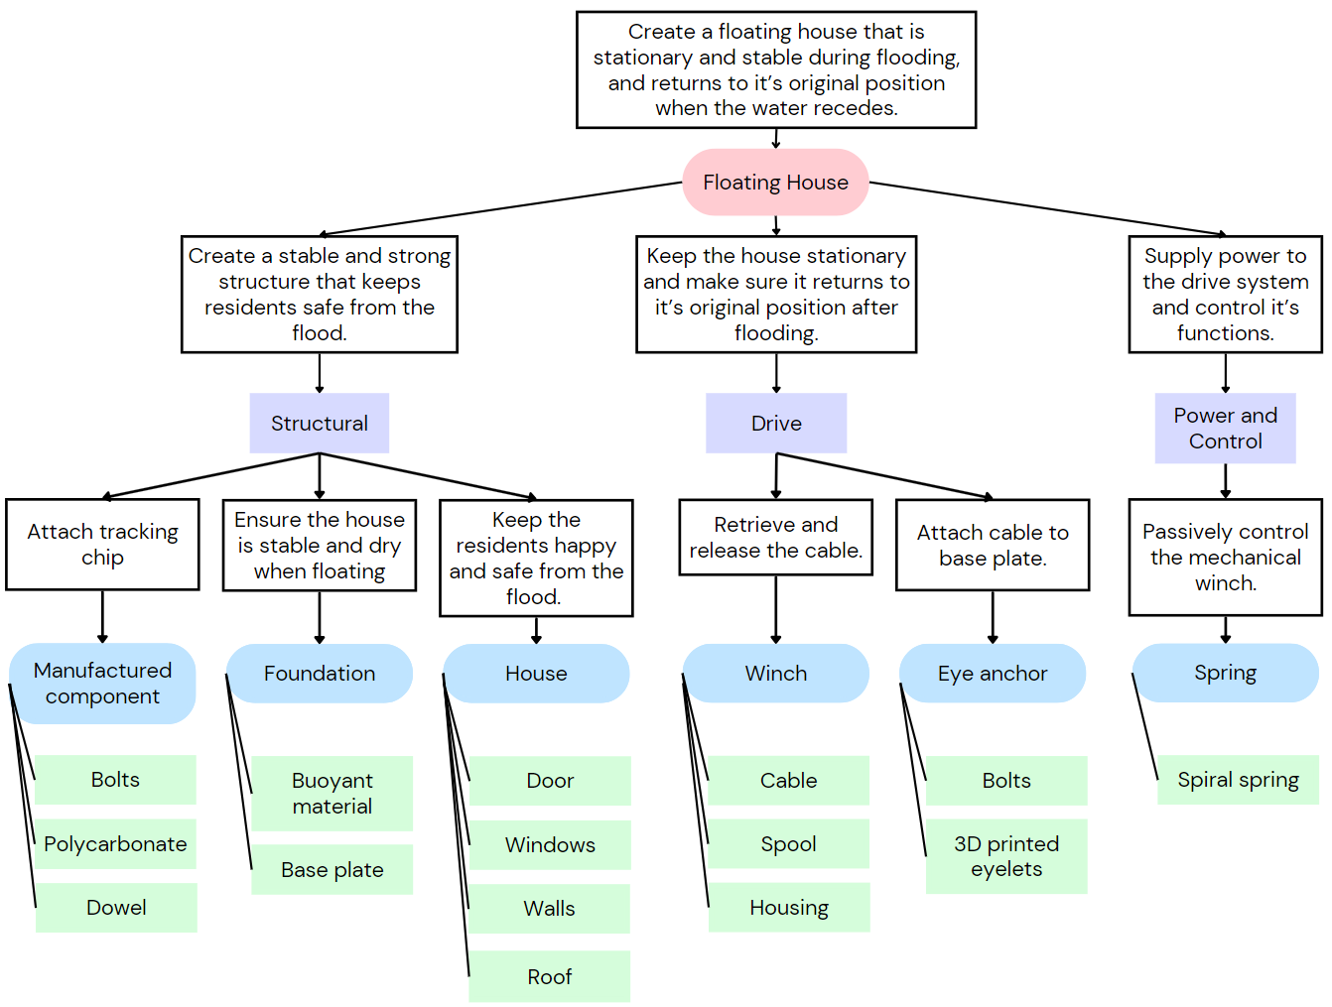

Figure 1: Function Means Tree

Decision analysis for the drive sub-system is performed below. The drive system must be able to return the structure to its origin position (Figure 1) and assist with the stability of the structure.

Table 1: Pair-Wise Comparison

|  |  |  |  |  |  |  |
| --- | --- | --- | --- | --- | --- | --- |
| Flood Resistant Housing | Cost - A | Stability and Safety - B | Station Keeping - C | Power Efficiency - D | Sum Total | Weighting |
| Cost - A |  | B | C | A | 1 | 0.166 |
| Stability and Safety - B |  |  | B | B | 3 | 0.5 |
| Station Keeping - C |  |  |  | C | 2 | 0.333 |
| Power Efficiency - D |  |  |  |  | 0 | 0.001 |

As shown in Table 1 a pairwise comparison was created to weight the importance of each criterion to determine the optimal solution for the design objectives. The weighting of each criterion was considered and ranked according to importance to the design; Safety/Stability, Station Keeping, Cost, Power Efficiency (Table 1). A decision-making matrix for the three solutions used this weighting to determine the optimal solution for the task. The solution of an electrical winch had a cumulative score of 2 in comparison to the solution of propellors with a cumulative score of 1.666 (Table 2). The solution of four mechanical winches was the best solution attaining a cumulative score of 2.334 (Table 2).

Table 2: Decision Making Matrix

|  |  |  |  |  |  |
| --- | --- | --- | --- | --- | --- |
| Drive System | Criteria A - Cost | Criteria B - Stability and Safety | Criteria C – Station Keeping | Criteria D - Power Efficiency | Sum Total |
| Weight | 0.166 | 0.5 | 0.333 | 0.001 | 1 |
| Solution A - Electrical Winch | 2 | 2 | 2 | 2 | 2 |
|
| Solution B – Four Mechanical Winches | 3 | 3 | 1 | 3 | 2.334 |
|
| Solution C – Propellors | 1 | 1 | 3 | 1 | 1.666 |
|

The first prototype solution uses an electrical winch in the centre of the prototype to counter the tilt and sway generated by the shifting centre of mass caused by the assessment box. The electrical winch uses a motor to control the amount of tension within the cable going directly through the structure to effectively maintain stability within the structure, therefore this solution received a 2 in Stability and Safety. The electrical winch provides sufficient tension within the string to adjust the position of the structure, hence was given a 2 for the criteria of Station Keeping. The tension within the string also provides stability to the structure by acting as a fixed cable support when in full tension. This solution uses a singular motor and a low number of electronics to generate movement within the electrical winch, hence received a 2 for both criteria of Cost and Power Efficiency.

The second solution uses a drive system containing four mechanical winches placed at each corner of the structure to counteract the tilt and sway generated from the shifting of the centre of mass within the assessment box. Hooke’s law states that the applied force (cable tension) is directly proportional to an increase in spring torsion (cable releases). This allows sufficient stability within the prototype as the four winches each have variable tension allowing the prototype to automatically self-stabilise resulting in this design receiving a 3 within the criteria of Stability and Safety. The four mechanical winches also counteract the movement within the assessment box as the four mechanical winches can adjust tension based on the position of the centre of mass caused by the rotating weight inside the test box. However, there’s no way of significantly moving the structure to its original position, hence received a 1 for the criteria of Station Keeping. This solution also can maintain the position of prototype using the tension within the cables acting like pulleys to resist external forces. This solution also received a 3 for the criteria of Cost and Power Efficiency as the prototype does not use motors or electrical components.

The third prototype solution uses a drive system containing two propellors on the same side with the ability the move in the x and y plane. The propellors provides sufficient movement to return the prototype to its original position using motors to control the speed of the propellors to return the prototype to the original position, resulting in this solution achieving a 3 in the criteria of Station Keeping. This solution can slightly counteract the shift in centre of mass within the assessment box using the buoyancy force created by the prototype, however the buoyancy force would need to be significantly greater than the tilt and sway generated by shifting centre of mass within the assessment box, hence received a 1 for Stability and Safety. This solution uses two motors and a vast number of electronics to control the propellors and therefore received a 1 in both criteria of Cost and Power Efficiency.

Table 3: Sensitivity Analysis

|  |  |  |  |  |  |
| --- | --- | --- | --- | --- | --- |
| Drive System | Criteria A  Cost | Criteria B  Stability and Safety | Criteria C  Station Keeping | Criteria D  Power Efficiency | Sum Total |
| **Weight** | 0.266 | 0.4 | 0.233 | 0.101 | 1 |
| **Solution A - Electrical Winch** | 2 | 2 | 2 | 2 | 2 |
|
| **Solution B – Four Mechanical Winches** | 3 | 3 | 1 | 3 | 2.534 |
|
| **Solution C – Propellors** | 1 | 1 | 3 | 1 | 1.466 |
|

The decision-making matrix was then adjusted by 10% to create a sensitivity analysis to confirm the scores were justified and determine if more investigation was required. The sensitivity analysis used weighting of Cost (0.266), Stability and Safety (0.4), Station Keeping (0.233) and Power Efficiency (0.101) (Table 3). This sensitivity analysis concluded that the solution using four mechanical winches obtained the highest cumulative score of 2.534 (Table 3). Whereas the solution utilising an electrical winch attained a cumulative score of 2 and the solution of propellors obtained a cumulative score of 1.466 (Table 3).

Using a decision-making matrix and sensitivity analysis it can be shown that the system solution utilising four mechanical winches for the prototype is the best solution for consideration, regarding the design constraints. This is based on the criteria of Cost, Safety and Stability, Station Keeping and Power Efficiency. Thus, the mechanical winches solution was selected for manufacturing and to be used in the small-scale prototype.

# Detailed Design

## Technical Specifications

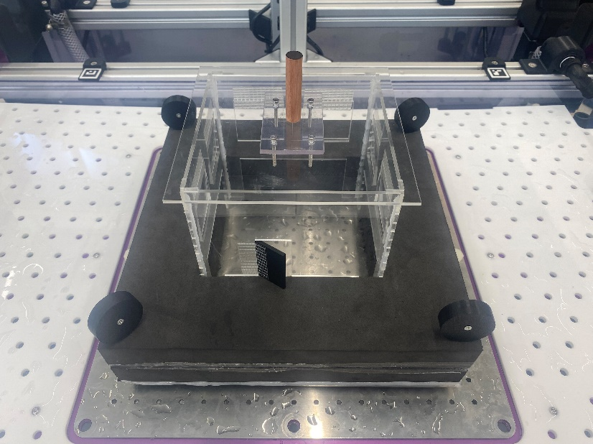

Figure 2: System level prototype

Each subsystem is detailed below:

### Structure

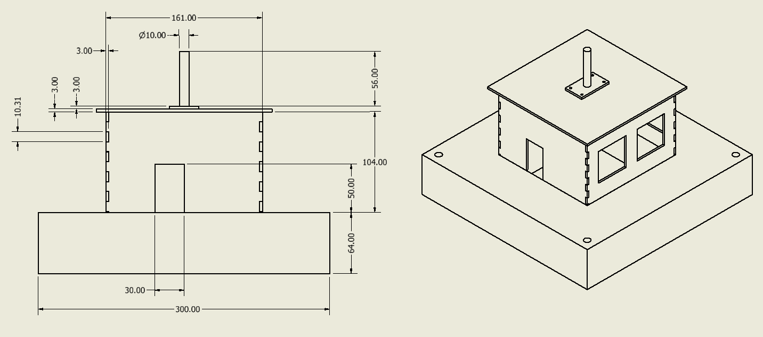

Figure 3: 3D Model of Prototype with measurements

As evident in Figure 3 the structure is within the dimensional constraints, being 300x300x230mm in size with a 30x50mm door, 50mm^2 windows, 64mm draft and a 155x155x150mm house volume. The house dimensions are symmetrical, hence the reason for only including the front view and isometric view. Note that the house is recessed into the foundation to meet the dimensional constraints. The manufactured component with the wooden dowel was placed on top of the build to ensure that the locator tag could be positioned at the stipulated height of 230mm.

High density closed cell EVA foam was selected for the construction of the foundation due to being lightweight and therefore buoyant in water (85kg/m3 (TitanAV, 2023)). Even though high-density foam is heavier compared to low-density, it is a worthwhile trade off to ensure the house is structurally strong. The house was made from acrylic to utilise the superior strength and non-porous attributes when compared to the lighter alternative of balsa wood. Each acrylic wall was laser cut with finger joints which ensured a strong connection when joined with glue. Multiple glues were tested for different parts of the build, including PVC, epoxy, silicone and hot glue. It was found that hot glue produced the strongest and quickest bond when gluing foam, and hence it was used to adhere most of the structure. The hinges for the doors and windows were created with fibreglass tape which is strong and waterproof. The door was 3D printed to be lightweight, and the windows came from the cut outs of the laser cutting process to prevent waste.

Multiple improvements were made to the first prototype to produce the final design pictured in Figure 2 and 3. Notably, the first prototype had the test box resting on top of the foam which resulted in very unstable tests. The problem was solved by recessing the floor which in turn lowered the centre of gravity of the final prototype.

### Drive

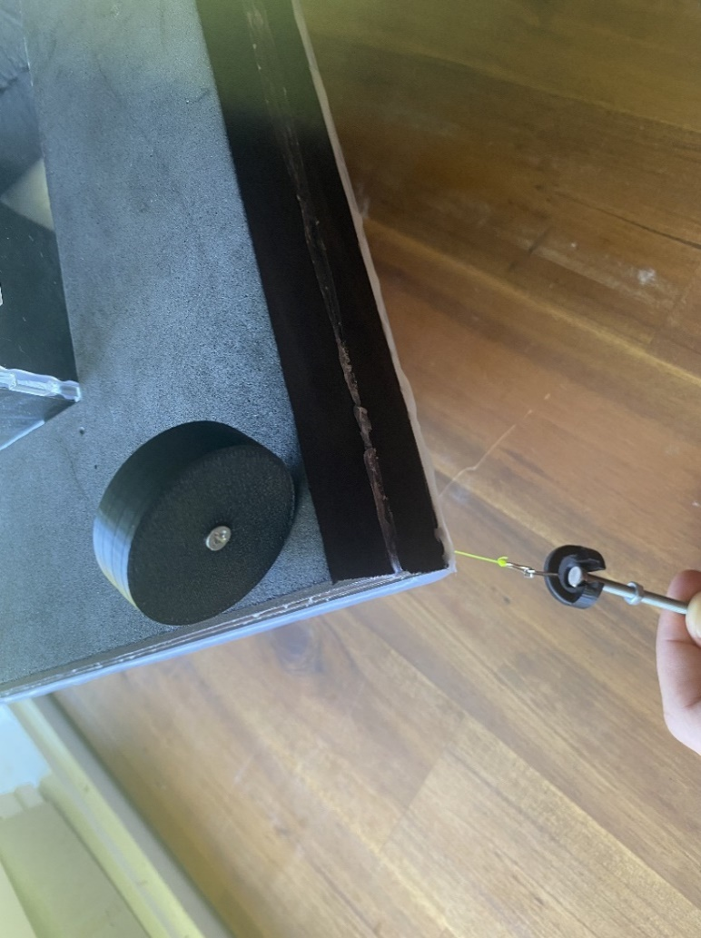

Figure 4: 3D printed mechanical winch

After three different iterations of the drive sub-system, Figure 4 displays the final solution. The drive is a passive system consisting of 4 mechanical winches powered by spiral springs inside which create tension in a cable that is attached to the base plate using a 3D printed eye bolt (See Figure 2 for configuration). The springs were bought off Ebay and the body of the winch was designed in CAD and 3D printed.

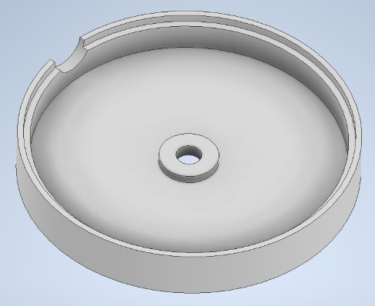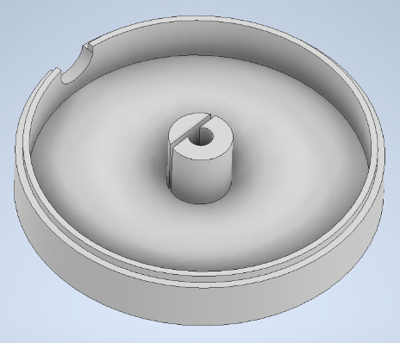

Figure 5: 3D Modelled Winch Body

Seven-kilogram monofilament fishing line was used as the winch cable due to its superior abrasion resistance compared to braided string and suppleness compared to braided wire. When comparing tests between passive (mechanical) and active (electronic) designs the results showed that passive control achieved the best test results. The design is light, compact, eliminates human error and does not require any electricity. Furthermore, the tension in the cables can be optimised by recalibrating the internal spring (increasing or decreasing the number of initial twists). These cables were run through each corner of the foundation with bamboo straws (strong and relatively non-porous) and then attached to the build plate with 3D printed eye bolts (See Figure 6 below).

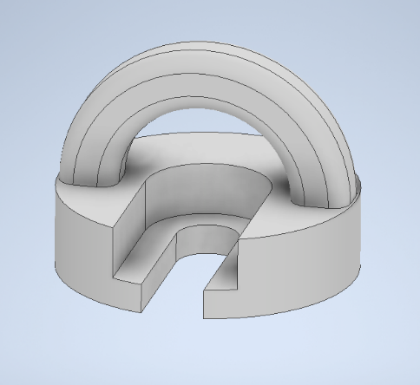

Figure 6: 3D Modelled Eye Bolt

### Power and Control

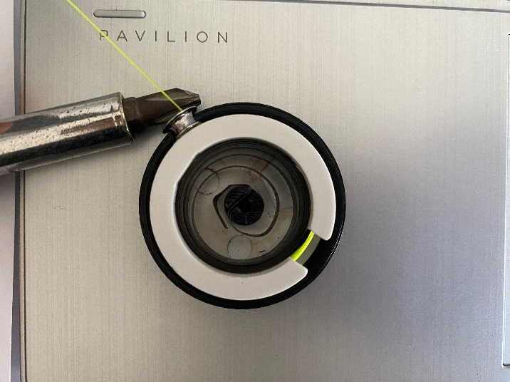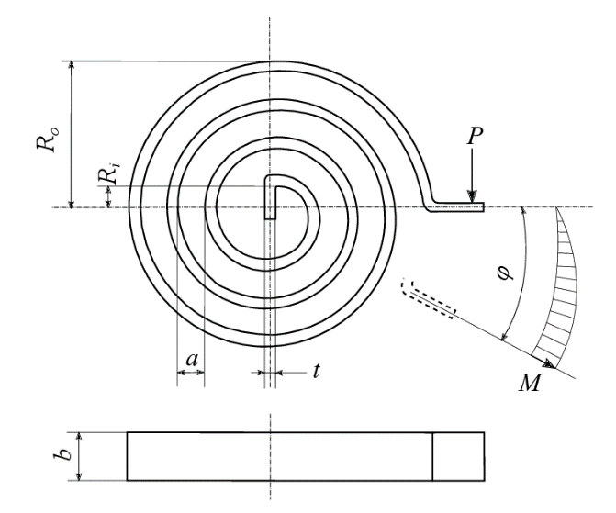

Figure 7: Spiral spring control system

As outlined above the drive system is completely passive. Therefore, it is the spiral spring (Figure 7) that stores elastic potential energy which supplies the mechanical power to the drive. This power is controlled through spring dynamics according to Hooke’s law. Hooke’s law states that the applied force (cable tension) is directly proportional to an increase in spring torsion (cable releasing). This is important because when the floating house is imbalanced to one side, the opposite side has more cable released and therefore higher cable tension which attempts to correct the pitch angle of the house (See test results in Figure 8).

### Budget

Table 4: Budget record

|  |  |  |  |  |
| --- | --- | --- | --- | --- |
| Item | Quantity Bought | Price | Quantity Used | Sub-total |
| 30mm EVA foam | 1000mm^2 | $63 | 300mm^2 | $5.67 |
| 3mm acrylic | 600mm x 400mm | $12.99 | 600mm x 400mm | $12.99 |
| Hot glue | 10 sticks | $2.99 | 4 sticks | $1.20 |
| Fibreglass tape | 10m | $9.99 | 50cm | $0.50 |
| 3D printing PLA filament | 1kg | $38.99 | 7g | $0.27 |
| Spiral springs | 4 | $10 | 4 | $10 |
| Bamboo straws | 10 | $4.04 | 2 | $0.81 |
| 7kg monofilament fishing line | 300m | $10.95 | 1.6m | $0.06 |
| M4 nuts and bolts | 6 | $3.74 | 4 | $2.49 |
| Total Cost | | $156.69 | Prototype Cost | $33.99 |

Table 4 demonstrates that the prototype only cost $33.99 of the $250 maximum project budget. This shows that the team was highly effective in managing the budget. The total cost of all the materials (used and unused) for the final prototype is $156.69 which is also under the $250 budget.

## Risk Analysis

Table 5: FMEA

|  |  |  |  |  |  |  |  |  |  |  |  |  |
| --- | --- | --- | --- | --- | --- | --- | --- | --- | --- | --- | --- | --- |
| **Item** | **Failure Mode** | **Causes** | **Effects** | **Risk Sev** | **Risk Prob** | **Risk Det** | **RPN** | **Improvement** | **Risk Sev** | **Risk Freq** | **Risk Det** | **RPN** |
| **Passive control**  **system** | **Broken Spring coil** | **Wear and fatigue** | **Tension is released and cables stop pulling** | **3** | **1** | **2** | **6** | **Ensure spring material is strong and spring is wound tightly** | **2** | **1** | **2** | **4** |
| **Drive**  **System** | **Stuck pulley** | **Motor breaks**  **Debris stuck** | **Spring loaded pulleys stop retracking and expelling cable.** | **3** | **1** | **1** | **3** | **Ensure smooth surfaces for pulley to make sure the wire does not get stuck.** | **3** | **1** | **1** | **3** |
| **Snapped wire** | **Too much stress on cable.** | **No positional stability.** | **3** | **2** | **1** | **6** | **Inspect cable strength and damage (if any).** | **3** | **1** | **1** | **3** |
| **Structure**  **System** | **Water Leak** | **Water floods into structure** | **Increases overall weight force. Sinks, Destroys Assessment Box/housing** | **4** | **2** | **2** | **16** | **Seal holes in the structure with silicone and other glues.** | **4** | **1** | **2** | **8** |
| **Unbalanced mass** | **Asymmetrical construction** | **Skews center of gravity to create a tilting moment. Does not resist moving mass in test box.** | **2** | **3** | **1** | **6** | **Build symmetry into structure and provide excess compensating buoyant force** | **2** | **2** | **1** | **4** |
| **Manufacturing Process** | **Inhaling airborne debris and fumes.** | **Production without PPE when using sander.** | **Potential lung cancer and other health effects.** | **3** | **2** | **3** | **18** | **Wear masks and turn on dust collector when airborne debris and fumes are exuded.** | **2** | **1** | **3** | **6** |
| **Injury from machinery** | **Appendage caught in open machinery** | **Loss and damage of appendage, causing amputation and bleeding.** | **3** | **2** | **4** | **24** | **Use proper operating procedures such as lowering guard on bandsaw.** | **2** | **1** | **4** | **8** |

Some of the risks that were expected during the manufacturing of the prototype are listed in the FMEA. For example, the inhalation of airborne debris during the refinement of the foam pads, where a belt sander was used to sand the foam to proper dimensions. To counteract this risk, the dust collector of the belt sander was turned on to extract the foam dust that was generated.

## Description of Prototype Operation

To begin operational testing of the prototype it is important to first demonstrate that individual parts of the prototype are functional. The operating procedure for the structural subsystem, once designed to dimensional specifications, is to first place the prototype structure onto the test rig and test through one or more full run cycles. With initial testing, observable issues with weighted tests showed that the draft height of the prototype was of concern when a 2.8kg weight was placed on the structure. When weighed down the structure would leave only a small 5-10mm gap between the water level and the floor. Additional concerns arose when the weights were shifted to one side, which caused the section to tilt below the water. The drive and control systems operate in unison autonomously and do not require any specific external control elements. The drive system mechanical winches are placed in the four corners of the prototype structure above the water level, eye bolts are to be fixed onto the base plate at an angle to the house and will be position so that the bolts do not touch the structure when at rest. The winch cables are attached to the 3D printed eye bolts using split rings which serve as a simple method of attaching the two components allowing for some angled movement. Tests were conducted on these mechanical winches to determine the minimum and maximum tension forces applied in the cable at different extension lengths (Figure 8).

Figure 8: Mechanical winch testing results

Figure 8 shows the range of tension force which can be applied on the winch before the spring reaches max torsion. On each winch the calculated minimum force is 4.38N and the maximum is 10.43N. Overall, these do provide resistive forces opposing the motion of wind and a variable force to oppose the weight, they also contribute to the net downward force. This led to a marked decrease in the factor of safety at 1.19 where a recommended factor is 1.2-2.0 for similar applications according to a study by Pricop, et al. in 2013.

The test box is to be placed into the structure of the house and the roof placed on top with the manufactured component part. To test the prototype each winch cable is attached to the eye bolts and the house is to be positioned at the centre of the testing platform. Then the model is allowed to remain uninterrupted throughout the tests as a passive system.

As previously stated, to solve the issue regarding the small margin between the house and the water level we first investigated improving our factor of safety by looking at increasing buoyancy, reducing weight or by increasing the heigh of our draft. Our approach to this involved recessing the test box into the foam layer, thereby removing excess weight from the foam and lowering the position of the centre of gravity. Furthermore, the house structure was re-design to use less acrylic and instead use struts to reduce weight. It was at this point a decision was made to remove electrical components entirely from the prototype, which by this stage we still hoped to implement. In initial tests an electrical winch was considered where a motor would vary the tension in a central string to improve position keeping. However, when testing with a motorised winch there was no significant improvement. Similarly, a redesign using a rotatable wheel system allowing for manual adjustment of the winch position was considered, and likewise, the additional weight from the electronics ultimately provided no improvement on the mechanical design. Additional tests demonstrated that the first iteration components used for the mechanical winches were unstable and ineffective due to physical imperfections in the spring and wire coil causing a high dynamic friction. Resulting in uneven extension

To fix these issues a new structural design was created, recessing the test box and removing a section of the foam layer increased the factor of safety to 1.34. Different iterations of the mechanical winch design were considered, allowing for modifications to the coiled force within the spring. These new winches were also smoother (nylon) and lighter than the first iteration (plastic vs metallic). Finally, testing with the test box in the structure with a full test cycle demonstrated that the fans, regardless of speed or orientation, do not affect the position of the prototype and display the effectiveness of the passive control and drive systems. We found from these tests that the shifting mass inside the test box would cause our design to tilt, leading to a stability score around 6 out of a possible 12. However, it also demonstrated the effectiveness of the drive and control system in maintaining positional displacement leading to a score of 29 for position. In all tests power efficiency remained at 10 out of 10 as the prototype is unpowered. Overall, in initial testing with the finalised prototype we observed testing scores of 44.8-46.4 out of a possible 50. To refine these scores the stability of the structure is the area with largest improvement potential, observational results underlined on the importance of setting an appropriate tension for each winch to significantly reduce the effects of tilting. Further a foam layer was included to reduce the empty space between the test box and the housing structure, in testing this caused the test box to shift to one side causing significant tilt in that direction.

On demo day the prototype successfully scored 47/50 (94%). The stability had been significantly improved; however, it was still the factor that scored the lowest with 7.1/10. Station keeping received an almost perfect score of 29.9/30 and power efficiency scored 10/10. This demonstrates the effectiveness of the improvements made to the prototype, and suggests the prototype is ready for real life implementation.

## Scale-Up Considerations

For the prototype to be scaled up to the scale of actual habitations, many changes would have to be made to make the final design feasible. For example, some materials of the structural subsystems would have to be updated due to the square cubed law, which states that as a structure increase in size in a power of two, the total mass of the structure would increase to the power of three (J. L. González, 2006). Thus, the materials would have to be exchanged for substitutions that are stronger, and thereby potentially more expensive, with that reason being why these materials were not used in the prototype.

Firstly, a suitable material substitute needs to be found for the foam. According to updated parameters, which consider the square cube law, the closed cell foam used in the final design should be swapped for closed cell aluminium foam, which is stronger, stiffer, and more resistant than the EVA foam used in the final design (Vedanta, 2023). This increase in resilience is necessary to combat the square cube law, with the real-life version having struts that run through the foam to give even more support to the foam encasement (SCAFCO, 2018).

Speaking of the foam encasement, there is an argument to be made to encase the floating foam foundation to prevent leakages with a layer of steel or aluminium alloy (SHM Group, 2018). While not necessarily essential for the floatation of the system, it does prevent, or at least resist the threat of flooding the foam. These two materials are the current mainstream options to build ship hulls, which would serve the same function as the foam encasement (SHM Group, 2018). They would prevent flooding and damages to the foam and are relatively lightweight compared to their strength.

Regarding the walls and floors of the actual house, mainstream options such as concrete and rebar are good options due to their strength to weight ratio, with timber being a legitimate option for its lightweight attributes and its potential to be sealed with advanced techniques such as charring (Wooden Floors UK, 2023).

As for the spiral springs within the mechanical winches, a heavy-duty motor and generators would have to be substituted to generate such torsion as there are no equivalent spiral springs on the market that can be scaled up to such a degree.

In real life, there is the opportunity to add a drainage plug to get rid of potentially damaging water that might originate from rain, like boat drain plugs at the bottom of modern boats. Another opportunity could be to add a bilge pump that acts as an extra precaution against leakages. A final opportunity is the ability to add lifeboats, spotlights, and sirens that can further increase the safety for occupants and nearby affected people.

As for the manufacturing process of the full-scale system, the production of aluminium would be difficult to do in one piece, therefore, the foam would have to be produced in separate sections. This, along with the advanced materials used for the full-scale system would result in considerably higher cost of materials and production compared to the scaled-down prototype (Tete, et al., 2022). Additionally, the ability to mass produce aluminium foam encounters limitations such as irregular cell growth, quality control and proper pore connectivity, adding to cost of production management (Tete, et al., 2022). However, with proper manufacturing procedures, these limitations could be overcome (Tete, et al., 2022).

One more limitation is the connection of vital infrastructure such as water, electricity and ethernet cables to the living space. These connections would get severed when the flooding occurs and the house begins to float away from the original location, so storage of water and electricity would have to be considered, as well as the development of self-sealing wires and pipes of these infrastructures that are able to be decoupled when the time comes. Alternatively, these infrastructures can be run along the cables connecting the foundation to the motors, but this solution presents the complication of how these infrastructures would be maintained and refitted over time (Tucker, N/A).

## Sustainability Assessment

Throughout the scaleup consideration, it is clear that the wall of the house will use timber, the buoyancy foundation will use aluminium foam, and the encasing of the foam will use aluminium alloy.

Table 6: Life Cycle Assessment

|  |  |  |  |  |
| --- | --- | --- | --- | --- |
| LCA Stage | Description | Material and/or Energy Inputs and Outputs (Direct) | Material and/or Energy Inputs and Outputs (In-Direct) | Environmental Impact |
| Resources and Raw Materials | - Wood from forests (forestry)  - Aluminium from bauxite (mining) | - Water  - Fuel  - Electricity | - Fertiliser  - Water  - Electricity  - Fuel | - Greenhouse gas emission  - Deforestation  - Habitat destruction |
| Material Processing / Preparation | - Wood processing to wood timbers  - Extracting bauxite ore, refine it to alumina.  - Smelt the alumina to extract pure aluminium | - Electric energy for processing  - Heat energy for processing  - Mechanical energy for processing | - Resources for infrastructure | - CO2 direct and indirect  - Greenhouse gas emission  - Fluoride emission  - Water usage  - Sulphur dioxide and nitrogen oxides emission. |
| Product Production | - Extrusion, rolling and foundry alloy | - Heat energy for processing  - Mechanical energy for processing | - Resources for infrastructure | - Greenhouse gas emission  - Fluoride emission |
| Distribution | - Packaging | - Packaging fuel  - Mechanical energy for packaging | - Fuel energy from transportation | - Greenhouse gas emission  - CO2 from fuel combustion  - Footprint from packaging |
| Use | - Waste packaging  - Cut into needed size | - Electricity | -None | - Air pollution from cutting aluminium |
| End of Life | - Recycle and reuse aluminium | - Water for cleaning  - Electricity for shredding | - Fuel energy for transportation | - Greenhouse gas emission  - Water usage |

# Team Reflection

Throughout the project, the team collaborated through various methods. The primary documentation and communication were done using the discord app (Figure 10). Specific features of the app were utilised by the team to optimise team interactions. Different text channels were created, allowing different points of discussion to be separated from each other. For example, there were channels dedicated to the drive subsystem, structure subsystem and power and control subsystem. There were also channels where members of the team could share receipts, research documents and other files. This ensured that project discussions were kept organised, and all members were up to date. In addition, the project team met on a weekly basis within a pre-booked library room (Figure 9) to ensure the team was on track with the project and to discuss any major concerns in person. The organisation surrounding the prototype’s build status and clear communication between team resulted in the team obtained a score of 7.1/10 for stability, 29.9/30 for station keeping, 10/10 for power efficiency during the assessed demonstration. This led to the team obtaining an overall score for the final test of 47/50 or 94% demonstrating the effectiveness of the solution for the task.

Figure 9: Discord Discussions Figure 10: Meeting Booking

The team approached the project with a group mindset. For both the oral presentation and final report, an online shared document was created to allow all members to see the progress of others and to allow multiple members to work at the same time. All tasks were split throughout the team so all members could contribute and to ensure the efficient use of time. The team utilised online discord calls to discuss any problems with the project and to ensure that all team members were keeping up to date with their tasks. All decisions were made through a team vote as this ensured a fair decision was made and every team member’s opinion was included. Overall, the team functioned well.

After analysing the team dynamics individually, *see appendix 2*, it was determined that the functionality of the team was at a high standard. However, the team agrees that communication between the subsystem groups could have been improved upon. During prototype building, the members of the power and control subsystem spent the majority of the time in the electronics lab while the rest of the team worked on the structure and drive subsystems of the prototype in the workshop. This often led to the members of the power and control subsystem group being left out of some decisions made to the overall prototype build. This meant that it was going to be more difficult to integrate the power and control subsystem into the prototype build. However, once a passive control system was decided on by the group and electronic components were no longer needed, the members of the power and control subsystem group were able to work in the workshop alongside the other members of the team and were kept updated. The team dynamics could have also been improved through working more efficiently. Team members being more organised for meetings would have led to a decrease in the amount of time being wasted. This would have improved the overall dynamics of the group. Overall, the team dynamics were at a high standard, however, some improvements could have been made.

# Conclusion and Recommendations

In providing an efficient, cost-effective, and practical prototype, team purple has designed and manufactured a scaled down model of a flood-resistant house able to withstand natural disasters. Initially, the Gantt chart provided the team finish the project by the end of week 12, and as such the final model was built on the 13/05/2024, giving 9 days distance from the project deadline. Since the planning phase the project has had numerous altercations to maximise power efficiency and stability, as well as minimising project costs.

To better conserve power consumption and buoyant stability, the decision was made to eliminate electronics and to implement a passive control including spring loaded pulleys at each corner. This method proved to be excellent as it gave the option of ignoring electronics which in turn removed a large portion of the project budget, eliminated the risks of human error and component failure, removed component weight increasing buoyancy, and simplified the project on a whole. This decision brought the project cost down to $33.99 ($156.69 when including unused materials) and presents itself as a simplistic and effective design for clients, benefitting stakeholders in every aspect.

In addition to improving the built model, future recommendations include using stronger and reliable materials for full scale systems. The current adhesives and materials would not be sufficient in the real world and would need harder, less penetrative substances to resist real-world conditions. The control and drive system would also need to be rendered to suit the weight and force required to maintain scaled house in its central position whilst in flood environments.

In summary, this project proved to be a success in manufacturing a scaled down solution for flood disasters providing a low-cost, low maintenance, simple, and durable design catering clients in flood-prone areas. This system has been tested to withstand the conditions of a flood event and has proved to be a quality product of team purple.

# References

Amaechi, C. V., Reda, A., Butler, H. O., Ja’e, I. A., & An, C. (2022). Review on Fixed and Floating Offshore Structures. Part I: Types of Platforms with Some Applications. *Journal of Marine Science and Engineering*, *10*(8). https://doi.org/10.3390/jmse10081074

*AS - load-bearing secure strut*. (2018, November 5). SCAFCO Steel Stud Company. https://www.scafco.com/steel/products/secure-clips/as-load-bearing-secure-strut/#:~:text=The%20load%2Dbearing%20secure%20strut

HYNE. (2022). *Advantages of Timber | Hyne Timber*. Hyne.com.au. https://www.hyne.com.au/why-timber/advantages-of-timber#:~:text=The%20manufacturing%20process%20of%20timber

IMS. (2018, October 3). *4 Types of Metal That Are Corrosion Resistant or Don’t Rust*. www.industrialmetalsupply.com. https://www.industrialmetalsupply.com/blog/4-types-of-metal-that-are-corrosion-resistant-or-dont-rust#:~:text=Aluminum%20alloys%20contain%20almost%20no

Jerz, J., Kováčik, J., Simancik, F., & Minár, P. (1997). Aluminium foam - A new light-weight structural material. *Kovove Materialy-Metallic Materials*, *35*, 265–277. https://www.researchgate.net/publication/279717768_Aluminium_foam_-_A_new_light-weight_structural_material

Luis González, J. (2006). *The Square Cube Law: from Vitruvius to Gaudi*. https://www.arct.cam.ac.uk/system/files/documents/vol-2-1323-1340-gonzalez-jl.pdf

Mahadev Madgule, C.G. Sreenivasa, & Borgaonkar, A. V. (2023). Aluminium metal foam production methods, properties and applications- a review. *Materials Today: Proceedings*, *77*, 673–679. https://doi.org/10.1016/j.matpr.2022.11.287

Mihail Pricop, Oncica, V., & Ionut Cristian Scurtu. (2013). FACTOR OF SAFETY IN OFFSHORE STRUCTURES DESIGN ACCORDING TO ENVIRONMENTAL LOADS. *“Mircea Cel Batran” Naval Academy Scientific Bulletin*, *XVI.*(152-157).

Morecambe Metals. (2021, June 30). *The Environmentally Friendly Properties of Aluminium Metal*. Morecambe Metals. https://www.morecambemetals.co.uk/the-environmentally-friendly-properties-of-aluminium-morecambe-metals/

Palmer, G. (2005). Boats and Things That Float. In *Physics for Game Programmers* (pp. 245–250). Apress Berkeley. https://doi.org/10.1007/978-1-4302-0021-5

Reinsch, W. A., & Benson, E. (2022). Decarbonizing Aluminum: Rolling Out a More Sustainable Sector. *Www.csis.org*. https://www.csis.org/analysis/decarbonizing-aluminum-rolling-out-more-sustainable-sector#:~:text=Aluminum%20production%20processes%20have%20changed

SHM. (2018, April 30). *Exploring the Hull Material Used in Modern Boat Design*. SHM Blog. https://www.shmgroup.com/blog/exploring-hull-material-used-modern-ship-design/

Tucker, B. (n.d.). *Modernizing Utility Infrastructure with Serial Connectivity*. Www.digi.com. Retrieved May 16, 2024, from https://www.digi.com/blog/post/modernize-utility-infrastructure-with-serial

Ukpanah, I. (2024, March 20). *Is Building With Wood Bad For The Environment? Stats, Trends And Facts*. GreenMatch.co.uk. https://www.greenmatch.co.uk/blog/is-building-with-wood-bad

University of Queensland. (2024). *Learning Guide* (1.1 ed.). University of Queensland.

Vaddi Thulasikanth, & Padmanabhan, R. (2023). Fabrication of sustainable closed-cell aluminium foams using recycled fly ash and eggshell powder. *Materials Today Communications*, *37*, 107302–107302. https://doi.org/10.1016/j.mtcomm.2023.107302

Vedanta. (2023). *Aluminium Foam: One Material, Innumerable Uses*. Vedantaaluminium.com. https://vedantaaluminium.com/blog/aluminium-foam-one-material-innumerable-uses/#:~:text=Featuring%20a%20rigid%20network%20of

Wannenburgh, K. (2024). *Concept Report*.

Wideline. (2024). *The Eco-Friendly Choice: How Timber Doors Can Help Reduce Your Carbon Footprint*. Wideline Windows & Doors. https://www.wideline.com.au/the-eco-friendly-choice-how-timber-doors-can-help-reduce-your-carbon-footprint/#:~:text=Timber%20is%20a%20renewable%20resource

Wooden Floors UK. (2023, January 9). *Wood Charring: A Match For Your Wooden Floor | Wooden Floors UK*. Woodenfloorsuk.com. https://woodenfloorsuk.com/blog/hardwood-flooring/wood-charring.html#:~:text=The%20charring%20process%20acts%20as

WorldWildlife (WWF). (2024). *Timber | Industries | WWF*. World Wildlife Fund. https://www.worldwildlife.org/industries/timber#:~:text=Consumption%20of%20tropical%20timber%20by

Xian, V. (2024). *Concept Report on Floating House*.

# Appendices:

## Appendix 1: Receipts for Materials

* EVA Foam: <https://www.titanav.co/products/eva-1000x1000x30mm-high-density-closed-cell-foam?pr_prod_strat=use_description&pr_rec_id=043d3a2d6&pr_rec_pid=6886978257105&pr_ref_pid=6887058505937&pr_seq=uniform>

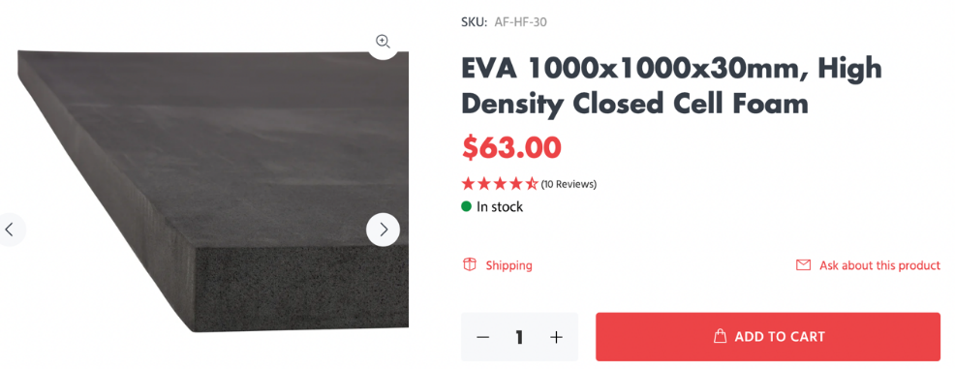

* Acrylic: <https://www.makerspace.uq.edu.au/buy-materials>

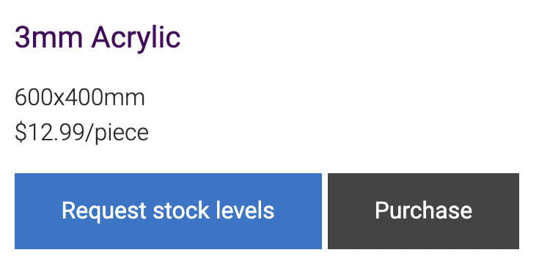

* Hot Glue: <https://www.officeworks.com.au/shop/officeworks/p/studymate-high-temperature-glue-gun-refills-10-pack-smhtgg10>
* A product on a product page

  Description automatically generated with medium confidence
* Fibre Glass Tape: <https://www.rebelsport.com.au/p/gray-nicolls-10m-fibreglass-bat-tape-561859.html>A close-up of a tape

  Description automatically generated
* PLA Filament: <https://au.store.bambulab.com/products/pla-basic-filament?variant=4321883163869> – Note only 7g were used resulting in a cost of $0.27 for the prototype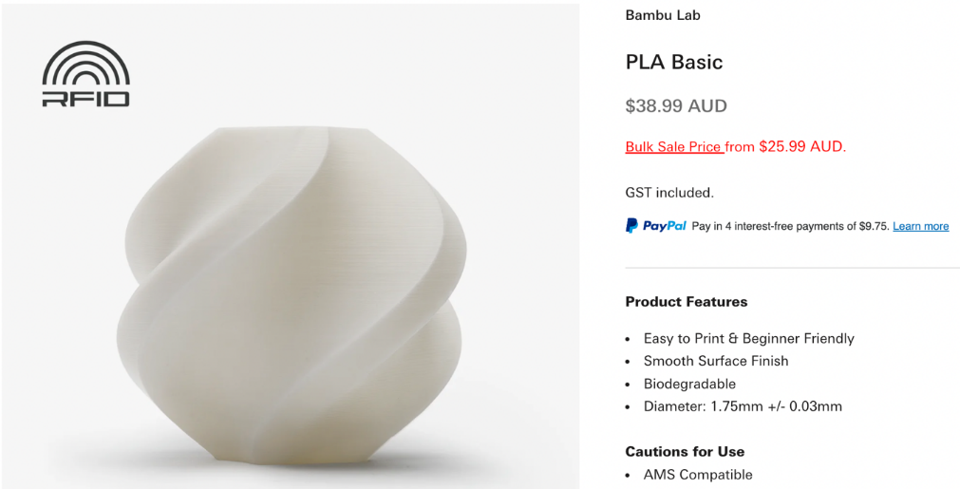
* Bamboo Straw: <https://www.temu.com/au/10-30-50-100pcs-disposable-bamboo-straws-for-milkshakes-smoothies-boba-bubble-tea-ice-coffee-perfect-for-home-bar-drink-shop-picnic-birthday-party-party-supplies-party-decor-g-601099539385463.html?top_gallery_url=https%3A%2F%2Fimg.kwcdn.com%2Fproduct%2Ffancy%2Fa3790338-e13a-4297-8fa2-62fae3a7826a.jpg&spec_gallery_id=2071820480&_x_vst_scene=adg&_x_ads_sub_channel=shopping&_x_ns_prz_type=-1&_x_ns_sku_id=17592312423764&_x_ads_channel=google&_x_gmc_account=710728018&_x_login_type=Google&_x_ads_account=2720833615&_x_ads_set=20878039836&_x_ads_id=157413511615&_x_ads_creative_id=685403347863&_x_ns_source=g&_x_ns_gclid=CjwKCAjwl4yyBhAgEiwADSEjeIiPoOoV5yg7VJkMmK2XfQ4qLcc9G9ki-LnnKjTJEwK6WWJw8tZBdBoC-OYQAvD_BwE&_x_ns_placement=&_x_ns_match_type=&_x_ns_ad_position=&_x_ns_product_id=710728018-17592312423764&_x_ns_target=&_x_ns_devicemodel=&_x_ns_wbraid=Cj8KCQjw9IayBhD6ARIuALxbvAYT64ffpTTRqsG0W6-lpFQmJA9aZKPs4Bel8VQUymttj2n12u6XFxJXzBoCa4I&_x_ns_gbraid=0AAAAAo4mICEGDORegfZ2HKg9WFDGx7ug8&_x_ns_targetid=pla-2086436374782&refer_page_name=kuiper&refer_page_id=14004_1715685983140_gvn4phb3ra&refer_page_sn=14004&_x_sessn_id=m9siralz43>



* 7Kg monofilament fishing line: <https://www.motackle.com.au/fishing/line/monofilament/jarvis-walker-hercules-mono-300m.html?fee=3&fep=76252&utm_source=google-shopping&utm_medium=cpc&child_sku=POS-190664&gad_source=1&gclid=CjwKCAjwl4yyBhAgEiwADSEjeLc5HRMKAZs8OR0MLyCzlgLoiYCM8bfO_gkCZl-94JW9x18rkcBzVBoCCk4QAvD_BwE>
* 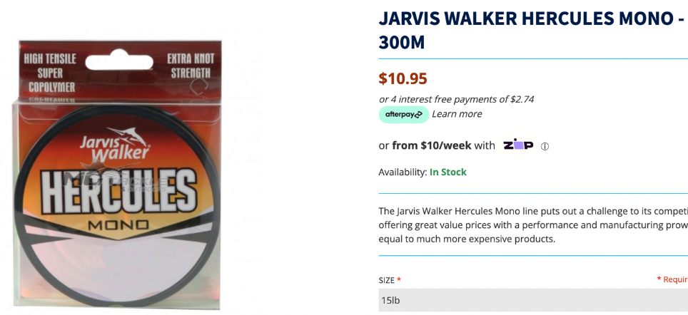
* M4 Nuts and Bolts: <https://www.bunnings.com.au/pinnacle-m4-x-50mm-zinc-plated-round-head-bolts-and-nuts-6-pack_p0168394?store=8057&gad_source=1&gclid=CjwKCAjwl4yyBhAgEiwADSEjeA53AYsqe6U_VnUjzM9Y9uLRGNC8QQlKIJ3hidd9hj_TxYW2RmQ-JxoCSr4QAvD_BwE&gclsrc=aw.ds>A screenshot of a website

  Description automatically generated

## Appendix 2: Team Members’ Critical Analysis

**Zavier:**

As a student of ENGG1100, I was faced with some challenges. However, I was rewarded heavily throughout my experience. I was unfortunately ill for a 5-week period and was unable to attend in-person meetings. Despite this, my team worked very hard to ensure that our project progression continued. I was kept informed and updated through the discord app. I was also able to continue to do my part for the team from home through researching and attending the online team meetings. I was particularly impressed with my team due to their enthusiasm to not only complete the course, but to excel within the subject. The team’s organisational skills ensured that tasks were completed with time to spare, enabling us time to reflect on our progress and make adjustments to the future plans of the project. Throughout the project, tasks were delegated equally throughout the team to ensure swift completion and to facilitate each members engagement within the project. The team had a strong view on fairness, meaning that all decisions were made using direct democratic processes involving hosting a team vote. Calvin and myself were tasked with the design, development and integration of the power and control subsystem. Calvin was an excellent project partner and we worked together to produce and effective and efficient control system. However, the team decided to utilise a passive control system which meant we were unable to use the control system designed by Calvin and myself. Despite not using the final subsystem design, I still learned from the experience through problem solving and being introduced to electronics, which was new for me. During my experience within the course, my professional engineering skills and teamwork ability was greatly refined. Overall, the team worked well together which encouraged me to participate with enthusiasm and led to me really enjoy the course.

**Kyle:**

Upon reflection of my journey through this team project, I am really grateful for being surrounding by a fantastic group of guys who are super motivated to ensure the success of our team. From day one we were all keen to get to know each other, and so we immediately started weekly meetings in the library. Each week we would organise what had to be completed and by when and share information we had gathered during the week. Every decision was made collaboratively and disputes were thankfully minimal. We ran into some challenges along the way with many team members getting sick and not being able to make our meetings, however everyone bounced back strongly. We were the only group in our pbl class to receive 100% for the oral presentation, one of the first groups to test our full scale prototype in week 7, and the first group to have a complete and working prototype (according to the supervising tutor). Overall, I think we worked really well as a team which has led to my enjoyment of this course.

**Vincent:**

Overall, at the end of this course and at the end of my time apart of this team I feel there has been so much individual development, for both my skills as a team member and as an engineer. Each member of this team has always been motivated to persevere in view of any challenges. Although there were times of struggle, when schedules did not align and when illness plagued the group, no member would abandon the team in our weekly in-person or online meetings, nor in task completion. Each task was sectioned and delegated out effectively. The team used online platform Discord to complete this project, the ability to share information, to coordinate online meetings and organise documents demonstrates the utter importance of strong communications skills. Regardless of how the team felt overall, even when deadlines hit and time frames were short, each person would always focus ensuring that no one was left out and no one was disadvantaged in any way. This project really embodies what it means to work in a team and to work well as a team, to work as professionals in the field and highlights on the importance of trust and good communication.

**Andrew:**

While writing this reflection, I think back to this project’s beginning. I think back to the PBL where I first met my team, introducing myself to strangers who would grow to become my trusted teammates. These enterprising future engineers who readily cooperate to join forces and work together to design and then build the best possible prototype according to the project objectives with the limited time and resources allocated. At the end of this project, I reflect on the effectiveness of clear communication and an efficient communication platform such as Discord. I think back to the weekly meetings we had on Wednesdays that were used to present design ideas and work on other tasks such as the oral presentation. During the project, we encountered challenges such as frequent sickness, which we rectified by reallocating tasks to other teammates, ensuring that no task was overlooked or forgotten. Overall, I am proud of myself, but more so of my team and their collective efforts to work together and finish the project in due time with minimal disagreements. Shout out to Kyle for coming up with many innovative drive ideas.

**Bryson:**

Upon completing this project, I reflect on its journey as a whole. I am grateful to be surrounded by a group with similar ideologies and to be able to complete it to the highest level possible. Unfortunately, I fell sick early on in the project and could not meet the group at first. However, I integrated myself within the team and project through the weekly meetings. During these meetings, the group would allocate tasks to each group member and share the tasks to be completed and tasks completed the previous week. We as a group faced some challenges, such as time to build the prototype, sickness, and very minimal decision disputes. To combat these challenges, we had a clear line of communication as a group. We used a democratic way of voting surrounding decisions, allowing the project to continue efficiently and effectively. These decisions allowed us to complete our initial prototype, oral presentation, and final prototype well before the initial timeline predicted. Allowing the group to create more defined prototypes, reports, and presentations, resulting in more effective solutions and better results within these areas.

**Calvin:**

In completing this project, I am thankful for being given to opportunity to work with such wonderful and proactive people. Reflecting on this course from meeting the team, to building and testing a final prototype was a great learning and fun experience which helped me personally and I believe the others too in being introduced to a professional environment. As head of the electronics side of the project, it was Zavier and I’s task to either manually operate or automate the winch system, however as a collective, we decided to go with a passive control using mechanical winches. This did not bother me as learning the electronics was both a course and personal endeavour which I am grateful for. It also allowed for the project to be bettered as it lowered cost, decreased weight, and benefitted the project on a whole. As a team, I believe our communication was on point, especially with Kyle being so organised and keeping us up to date. We used discord and PBL sessions as well as a weekly 2-hour meeting either in person or online for building, discussion, and checking in. The discord platform allowed document sharing including receipts, documents, pictures and all the other required documents needed throughout the project. The team worked in sub-systems which allowed us to work to our strength or our future disciplines and together we finish a complete working prototype which has been tested thoroughly. Overall, the democratic and kind atmosphere allowed us to create a prototype which is greatly prepared for the demonstration.

**Chris:**

Throughout the course, I am truly grateful for being surrounded by such an awesome group that I had never met before. Reflecting on our journey, we faced several challenges while working on our project. Members falling ill, causing them to miss our weekly Wednesday morning meetings. Despite this, at the end we still met up as a team to build the prototype, and everyone contributed. It was a lot of fun facing problems together and resolving them as a team. We also dealt with the recuring problem of broken parts of the prototype and differing system ideas, which requires us to remake the prototype about 3 times with 3 different designs. Initially we had many cool and innovative solutions for the drive subsystems, mainly Kyle that came up all the cool drive subsystem solutions. However, on our first and second prototype, we found that it was too heaver for the project to float on the water, forcing us to switch to passive control using ID card holders with its tensioning cables. This change meaning that we could achieve full marks for power efficiency, which was great. Different opinions with the team were resolved collaboratively through voting, ensuring all voices were heard. Despite all these challenges, we stayed connected using the app Discord. We have a 1100 Purple Team group chat to share information and stay in touch. I can still remember practicing our presentation and rehearsing our script right before the PBL lesson, but it was worth it since we were the only group to achieve a 100% score in our PBL class. Overall, our journey showed the importance of teamwork, flexibility, and perseverance in overcoming obstacles.